**Bob McCormick**

I’ve been involved with the visual arts since childhood making 8mm films and comic strips. My drawings were published by local media venues and took me on to receive a fine arts degree from the University of Arizona. After graduation I relocated to Germany and was admitted into the Kunstverien Stuttgart, the local arts association, where I marketed architectural pen and ink drawings and took up photography. After returning to the U.S., I was introduced to the airbrush while working in an art store in Washington D.C.which became my main tool for paint applications.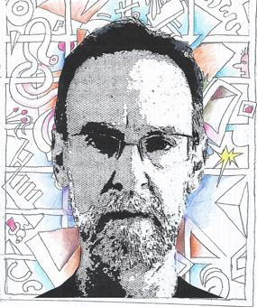

I know there is a kind of matrix involving mind, body, and soul that when they are in sync something meaningful happens. My formal training introduced me to the concepts of Surrealism and the color theories of Fauvism which I’ve embraced as the foundation of my work. If I had to classify the results of my experiments, I would call them abstract pop surrealist paintings.

I feel my pieces involve more engineering and differing skill sets than traditional brush painting. Airbrush technique requires stencils and different approaches to color mixing. The process I go through begins with creating a blueprint of auto-drawings aka doodles which I then colorize. Originally the application of paint was sprayed on in an attempt to eliminate any bias brushstrokes would invoke. Now I incorporate different mediums and applications to add texture in order to enhance the clean look of airbrushing.